上机实验3

实验一:
代码：
#include<iostream>
#include<cmath>
//#include<string>
using namespace std;

class coordinate {
private:
int times;
float a[100][2];
public:
coordinate();
coordinate(int times1);
~coordinate();
void input();
void show();

};

coordinate::coordinate()
{
times = 2;
cout << "Coordinate construction1 called! " << endl;
}

coordinate::coordinate(int times1)
{

if (times1 > 100)
times1 = 100;
times = times1;
cout << "Coordinate construction2 called! " << endl;
}

coordinate::~coordinate()
{
cout << "Coordinate disconstruction called! " << endl;
}

void coordinate::input()
{
int i;
for ( i = 0; i < times; i++)
{
cout << "Please input x: " << endl;
cin >> a[i][1];
cout << "Please input y: " << endl;
cin >> a[i][2];
}
}

void coordinate::show()
{
int n;
float avgx=0,avgy=0;
for (n = 0; n < times; n++)
{
avgx = avgx + a[n][1];
avgy = avgy + a[n][2];
}
avgx = avgx / times;
avgy = avgy / times;
cout << "Yuor numbers are: " << endl;
for (n=0;n<times;n++)
{
cout << a[n][1] << " " << a[n][2] << endl;
}
cout << "The averages are: " << endl;
cout << "X is : " << avgx << " " << "Y is : " << avgy << endl;
}

int main()
{
int t;
cout << "How many groups will you input? " << endl;
cin >> t;
coordinate coord(t);
coord.input();
coord.show();
return 0;
}

图片：
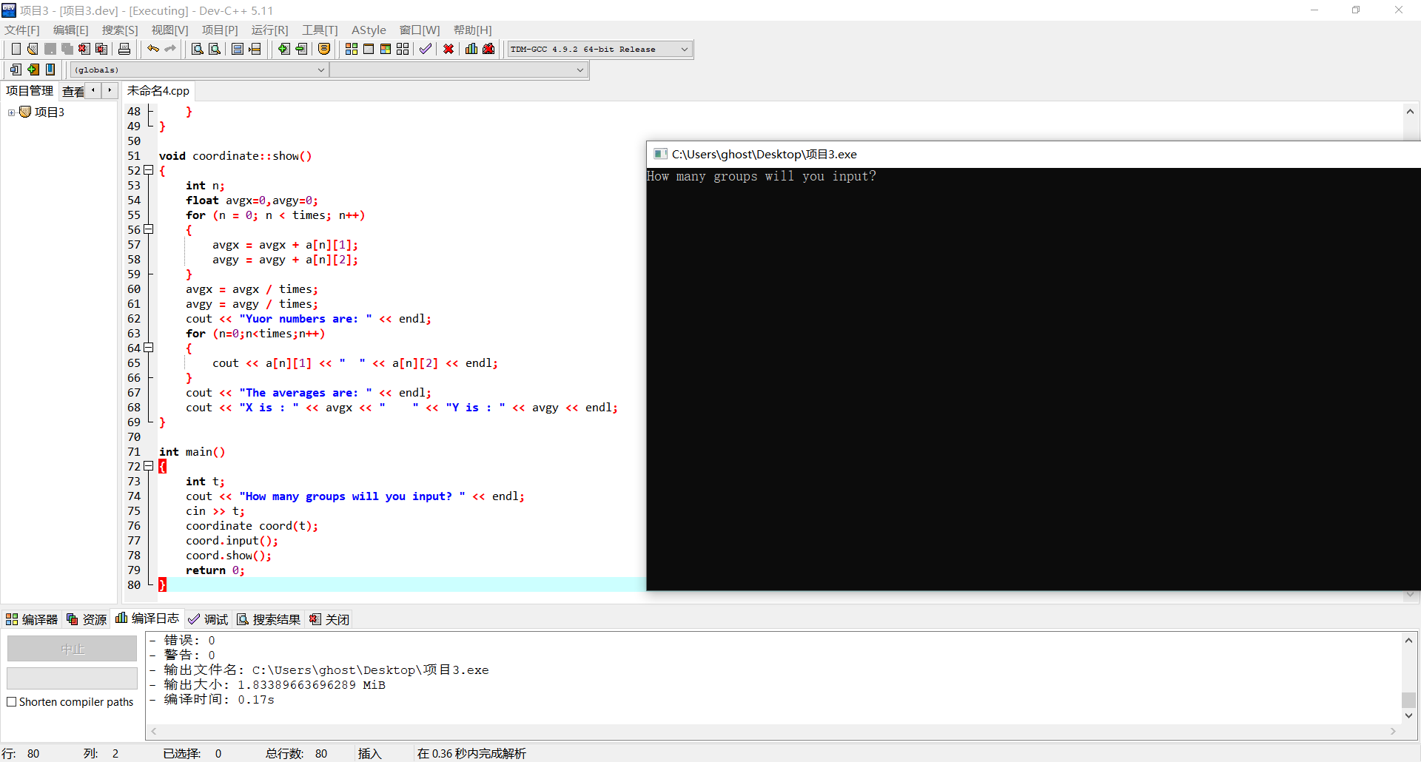
实验二：
代码：
//Tips:You are allowed to input 100 students at most !
#include<iostream>
#include<cmath>
#include<string>
using namespace std;

class coordinate {
private:
int times;
float a[100][3];
string b[100];
public:
coordinate(int times1);
void input();
void show();

};

coordinate::coordinate(int times1)
{

if (times1 < 2)
times1 = 2;
times = times1;
//cout << "Coordinate construction2 called! " << endl;
}

void coordinate::input()
{
int i;
for ( i = 0; i < times; i++)
{
cout << "Please input student's name: " << endl;
cin >> b[i];
cout << "Please input score of courseA: " << endl;
cin >> a[i][1];
cout << "Please input score of courseB: " << endl;
cin >> a[i][2];
cout << "Please input score of courseC: " << endl;
cin >> a[i][3];
}
}

void coordinate::show()
{
int n,m;
float avgA=0,avgB=0,avgC=0,avgD;
for (n = 0; n < times; n++)
{
avgD = 0;
cout << "Name: " << b[n] << endl;
cout << "courseA: " << a[n][1] << " " << "courseB: " << a[n][2] << " " << "courseC: " << a[n][3] << endl;
avgD = (a[n][1] + a[n][2] + a[n][3]) / 3;
cout << "The average score of this student is: " << avgD << endl;
}

for (n = 0; n < times; n++)
{
avgA = avgA + a[n][1];
avgB = avgB + a[n][2];
avgC = avgC + a[n][3];
avgA = avgA / times;
avgB = avgB / times;
avgC = avgC / times;
}
cout << "The average score of courseA is: " << avgA << endl;
cout << "The average score of courseB is: " << avgB << endl;
cout << "The average score of courseC is: " << avgC << endl;
}

int main()
{
int t;
cout << "How many students will you input? " << endl;
cin >> t;
coordinate coord(t);
coord.input();
coord.show();
return 0;
}
图片：
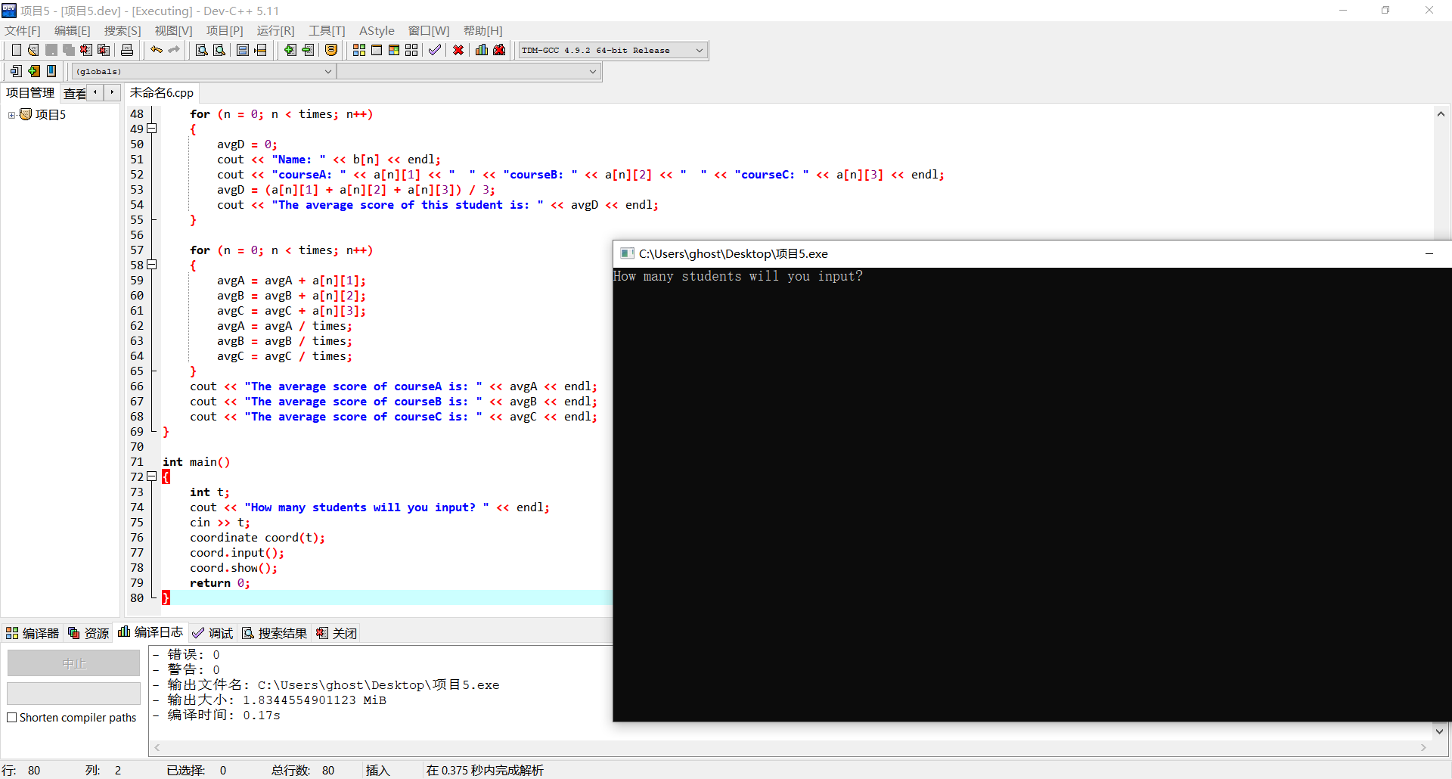

总结：
本次实验使我学会了构造函数与析构函数的调用顺序，并了解了它们的特性，加深我对其运用的理解。

Copyright @2021-2099 ShanzhengZhang. All rights reserved

